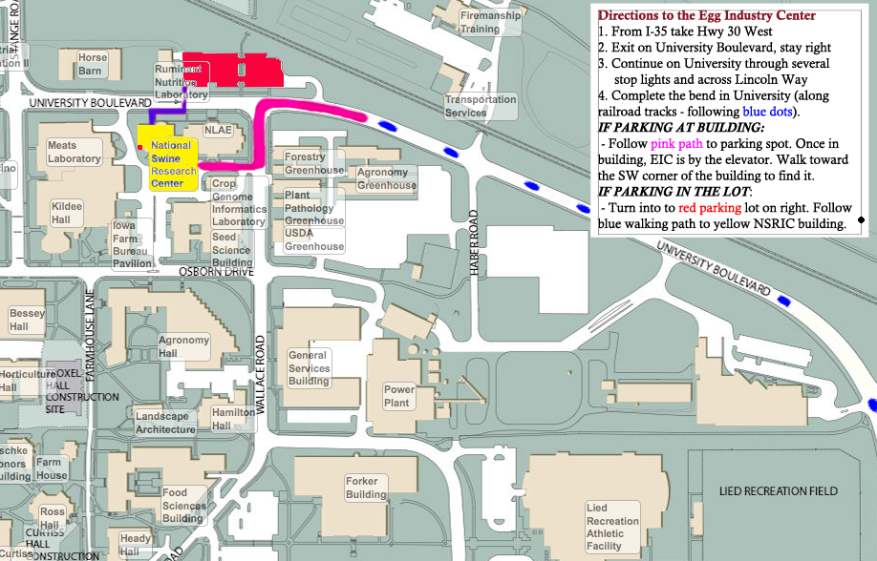

**When crossing Lincoln Way**, call 515.294.4037 (office) or 515.491.0402 (cell) and someone will meet you with the parking pass you need.